**ABSTRACT**

This paper is scrutinizes the use of different concepts of applets in JAVA programming language, enabling viewer to get the complete concept of different aspects of JAVA programming. Java applets were small applications written in the Java programming language, or another programming language that compiles to Java bytecode, and delivered to users in the form of Java bytecode. To satisfy this we created a simple Java Applet program displaying a Traffic Signal System.

**TABLE OF CONTENT**

|  |  |  |
| --- | --- | --- |
| Sr.No. | Topic Name | Page No. |
| 1 | Introduction   1. Java 2. Applet | 3-6  3  5 |
| 2 | Design Implementation   1. Algorithm 2. Flowchart 3. Code | 7-10  7  8  9 |
| 3 | Output and Analysis   1. Output 2. Analysis | 11-12  11  12 |
| 4 | Conclusion and Future Enhancement   1. Conclusion 2. Future Enhancement | 13  13  13 |
| 5 | References | 14 |

**Introduction**

1. **Java:**

Java is a high-level, class-based, object-oriented programming language that is designed to have as few implementation dependencies as possible. It is a general-purpose programming language intended to let application developers write once, run anywhere (WORA), meaning that compiled Java code can run on all platforms that support Java without the need for recompilation. Java applications are typically compiled to bytecode that can run on any Java virtual machine (JVM) regardless of the underlying computer architecture. The syntax of Java is similar to C and C++, but has fewer low-level facilities than either of them. The Java runtime provides dynamic capabilities (such as reflection and runtime code modification) that are typically not available in traditional compiled languages. As of 2019, Java was one of the most popular programming languages in use according to GitHub, particularly for client-server web applications, with a reported 9 million developers.

Java was originally developed by James Gosling at Sun Microsystems (which has since been acquired by Oracle) and released in 1995 as a core component of Sun Microsystems' Java platform. The original and reference implementation Java compilers, virtual machines, and class libraries were originally released by Sun under proprietary licenses. As of May 2007, in compliance with the specifications of the Java Community Process, Sun had relicensed most of its Java technologies under the GNU General Public License.



Fig.1. Java Programming Language

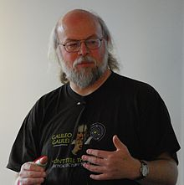

Fig.2. James Gosling - Creator of Java



Fig.3. Sun Microsystems

1. **Java Applet**

Java applets were small applications written in the Java programming language, or another programming language that compiles to Java bytecode, and delivered to users in the form of Java bytecode. The user launched the Java applet from a web page, and the applet was then executed within a Java virtual machine (JVM) in a process separate from the web browser itself. A Java applet could appear in a frame of the web page, a new application window, Sun's AppletViewer, or a stand-alone tool for testing applets.

Java applets were introduced in the first version of the Java language, which was released in 1995. Beginning in 2013, major web browsers began to phase out support for the underlying technology applets used to run, with applets becoming completely unable to be run by 2015–2017. Java applets were deprecated since Java 9 in 2017.

Java applets were usually written in Java, but other languages such as Jython, JRuby, Pascal, Scala, or Eiffel (via SmartEiffel) could be used as well.

Java applets run at very fast speeds and until 2011, they were many times faster than JavaScript. Unlike JavaScript, Java applets had access to 3D hardware acceleration, making them well-suited for non-trivial, computation-intensive visualizations. As browsers have gained support for hardware-accelerated graphics thanks to the canvas technology (or specifically WebGL in the case of 3D graphics), as well as just-in-time compiled JavaScript, the speed difference has become less noticeable.

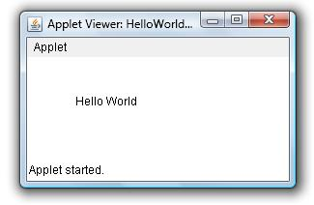

Fig.4. Basic Java Applet

**Versions:**

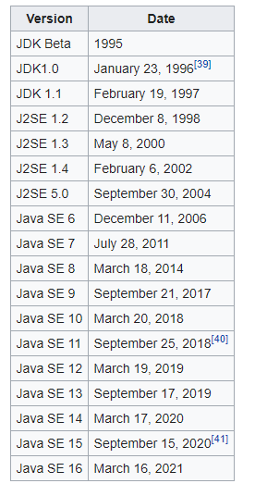

**Design/Implementation:**

**Algorithm:**

1. Start
2. Import java.applet
3. Import java.awt
4. Import java awt.event
5. Declare Applet “Signal”
6. Checkbox Statement
7. If String msg = “Stop”, then go to step
8. If String msg = “Ready”, then go to step
9. If String msg = “Go”, then go to step
10. Initiate Class Graphics
11. Execute msg.equals("Stop")()
12. Execute msg.equals("Ready")()
13. Execute msg.equals("Go")()
14. Stop

**Flowchart:**

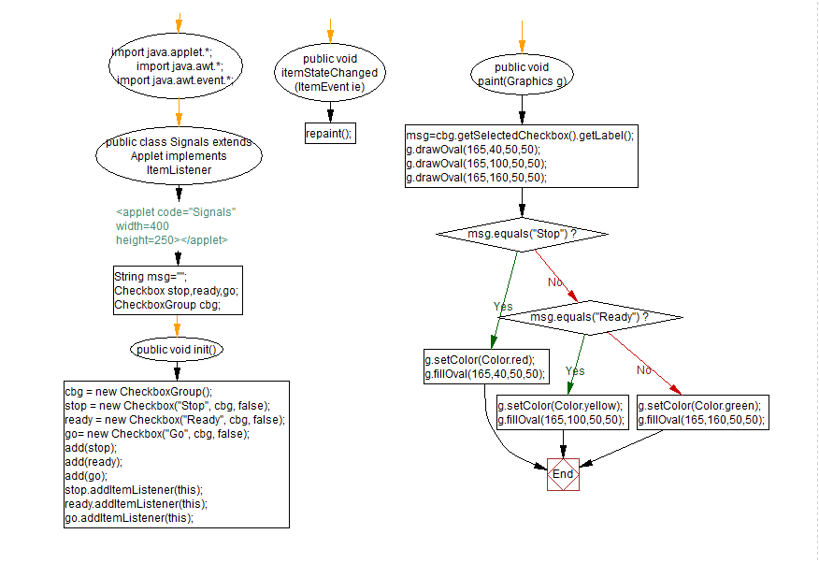

Fig.5. Flowchart

**Code:**

**import java.applet.*;**

**import java.awt.*;**

**import java.awt.event.*;**

**/*<applet code="Signals" width=400 height=250></applet>*/**

**public class Signals extends Applet implements ItemListener**

**{**

**String msg="";**

**Checkbox stop,ready,go;**

**CheckboxGroup cbg;**

**public void init()**

**{**

**cbg = new CheckboxGroup();**

**stop = new Checkbox("Stop", cbg, false);**

**ready = new Checkbox("Ready", cbg, false);**

**go= new Checkbox("Go", cbg, false);**

**add(stop);**

**add(ready);**

**add(go);**

**stop.addItemListener(this);**

**ready.addItemListener(this);**

**go.addItemListener(this);**

**}**

**public void itemStateChanged(ItemEvent ie)**

**{**

**repaint();**

**}**

**public void paint(Graphics g)**

**{**

**msg=cbg.getSelectedCheckbox().getLabel();**

**g.drawOval(165,40,50,50);**

**g.drawOval(165,100,50,50);**

**g.drawOval(165,160,50,50);**

**if(msg.equals("Stop"))**

**{**

**g.setColor(Color.red);**

**g.fillOval(165,40,50,50);**

**}**

**else if(msg.equals("Ready"))**

**{**

**g.setColor(Color.yellow);**

**g.fillOval(165,100,50,50);**

**}**

**else**

**{**

**g.setColor(Color.green);**

**g.fillOval(165,160,50,50);**

**}**

**}**

**}**

**Output and Analysis**

**Output:**

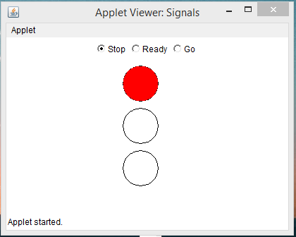

Fig.6. Stop

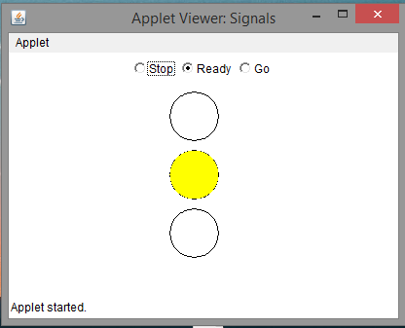

Fig.7. Ready

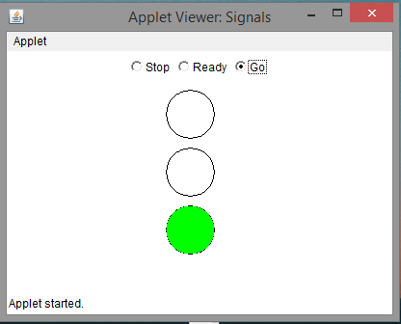

Fig.8. Go

**Analysis:**

As of March 2021, the latest version is Java 16, with Java 11, a currently supported long-term support (LTS) version, released on September 25, 2018. Oracle released the last zero-cost public update for the legacy version Java 8 LTS in January 2019 for commercial use, although it will otherwise still support Java 8 with public updates for personal use indefinitely. Other vendors have begun to offer zero-cost builds of OpenJDK 8 and 11 that are still receiving security and other upgrades.

Oracle (and others) highly recommend uninstalling outdated versions of Java because of serious risks due to unresolved security issues. Since Java 9, 10, 12, 13, 14, and 15 are no longer supported, Oracle advises its users to immediately transition to the latest version (currently Java 16) or an LTS release.

Pages coded in HTML may embed parameters within them that are passed to the applet. Because of this, the same applet may have a different appearance depending on the parameters that were passed.

As applets were available before HTML5, modern CSS and JavaScript interface DOM were standard, they were also widely used for trivial effects such as mouseover and navigation buttons. This approach, which posed major problems for accessibility and misused system resources, is no longer in use and was strongly discouraged even at the time.

**Conclusion and Future Enhancement**

**Conclusion:**

Java is a high-level, class-based, object-oriented programming language that is designed to have as few implementation dependencies as possible. It is a general-purpose programming language intended to let application developers write once, run anywhere, meaning that compiled Java code can run on all platforms that support Java without the need for recompilation. Programs written in Java have a reputation for being slower and requiring more memory than those written in C++. However, Java programs' execution speed improved significantly with the introduction of just-in-time compilation in 1997/1998 for Java 1.1.

The applets are used to provide interactive features to web applications that cannot be provided by HTML alone. They can capture mouse input and also have controls like buttons or check boxes. In response to user actions, an applet can change the provided graphic content. This makes applets well-suited for demonstration, visualization, and teaching. There are online applet collections for studying various subjects, from physics to heart physiology. As applets were available before HTML5, modern CSS and JavaScript interface DOM were standard, they were also widely used for trivial effects such as mouseover and navigation buttons. This approach, which posed major problems for accessibility and misused system resources, is no longer in use and was strongly discouraged even at the time.

**Future Enhancement:**

The Java programming language requires the presence of a software platform in order for compiled programs to be executed.Oracle supplies the Java platform for use with Java. The Android SDK is an alternative software platform, used primarily for developing Android applications with its own GUI system.

Most browsers executed Java applets in a sandbox, preventing applets from accessing local data like the clipboard or file system. The code of the applet is downloaded from a web server, after which the browser either embeds the applet into a web page or opens a new window showing the applet's user interface.

The Java language is a key pillar in Android, an open source mobile operating system. Although Android, built on the Linux kernel, is written largely in C, the Android SDK uses the Java language as the basis for Android applications but does not use any of its standard GUI, SE, ME or other established Java standards.

Java system libraries and runtimes are backwards-compatible, allowing one to write code that runs both on current and on future versions of the Java virtual machine.

**References**

1. <https://en.wikipedia.org/wiki/Java_applet>
2. <https://en.wikipedia.org/wiki/Java_(programming_language)>
3. Chaudhary, Harry H. (July 28, 2014). "Cracking The Java Programming Interview :: 2000+ Java Interview Que/Ans"
4. Chan, Rosalie (January 22, 2019). "The 10 most popular programming languages, according to the 'Facebook for programmers'". Business Insider. Archived from the original on June 29, 2019. Retrieved June 29, 2019.
5. In the summer of 1996, Sun was designing the precursor to what is now the event model of the AWT and the JavaBeans component architecture. Borland contributed greatly to this process. We looked very carefully at Delphi Object Pascal and built a working prototype of bound method references in order to understand their interaction with the Java programming language and its APIs.White Paper About Microsoft's Delegates